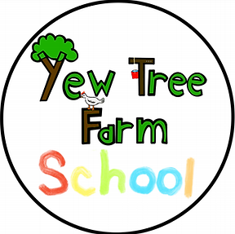
Yew Tree Farm School - Student Behaviour Policy

As a student of Yew Tree Farm School it is important that you understand and agree to the following:

- I will listen to instructions and do what I have been asked, straight away.
The farm can be dangerous sometimes, with animals and machinery. You have to follow instructions when asked so that you can stay safe.

- I will be kind to others with my words and actions
Kindness is really important at the farm! We are kind to students, staff, visitors and animals.

- I will allow others to learn and not disturb them.
Other students are busy learning onsite too, everyone needs the opportunity to enjoy the farm.

- I will always try my best.
Sometimes there are jobs we don’t want to do, or feel like we aren’t very good at, but at the farm everyone tries their best and supports each other.

- I will be respectful of other people’s belongings
I will look after equipment on the farm and not touch things that belong to other people.

Sometimes we can all struggle with our feelings though! When you are feeling angry, frustrated, worried or not able to follow instructions then you can take a TIME OUT.
This is not a punishment!
When you need it, you can take time to calm down and relax on one of our picnic benches. Here you will be safe and given some space. You can then join back in when you are ready.
A member of staff might suggest you take a TIME OUT if you are struggling to follow the rules. Remember this is NOT a punishment, but is a chance for you to refocus.

What happens if I continue to not follow the rules?
If you are still struggling then another member of staff will join your session. Try to talk to them about how you are feeling. Remember we are here to help!

If your behaviour means that you or others are no longer safe then staff will remove you from the situation. You will be asked to move to a safe space, if you do not do so then staff will hold your elbows and guide you somewhere safe.

If we are unable to keep you safe on site, or you continually endanger others then your parent or carer will be called to collect you. We will then decide whether we can safely allow you to come back another day.

All the staff at Yew Tree Farm School are here to help you, and want you to succeed! Talk to us when you are struggling and we can work together.

