Yew Tree Farm School – Executive Board
The Executive Board provides strategic oversight, accountability and support to the leadership of Yew Tree Farm School. The Board ensures that the school’s vision, values and statutory responsibilities are upheld, offering challenge and guidance to promote high‑quality education, safeguarding, and positive outcomes for children and young people.

Hilary Macdonald – Executive Chair
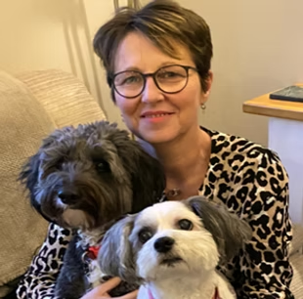
Hilary Macdonald is an experienced senior school inspector and former headteacher. She has worked extensively with local authorities and schools to improve standards, leadership and safeguarding.

Stephen Grix OBE – Board Member

Stephen Grix OBE has held senior leadership roles in further education, including as a college principal. He has also worked with Ofsted and brings extensive experience in governance and educational strategy.

Dr Abie Alfrey – Board Member
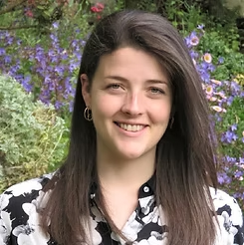
Dr Abie Alfrey is a clinical psychologist specialising in child and adolescent mental health. Her work focuses on trauma‑informed and nature‑based approaches to supporting children with SEMH needs.

Jackie Noble – Board Member
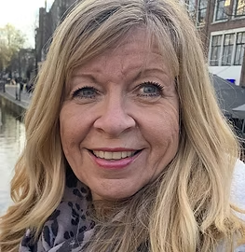
Jackie Noble is an experienced education professional with leadership experience across secondary and specialist education. She brings expertise in curriculum development and school improvement.

Karen Baker – Board Member

Karen Baker has a background in further education and the charity sector. She has extensive experience supporting vulnerable learners and developing inclusive, trauma‑informed practice.

