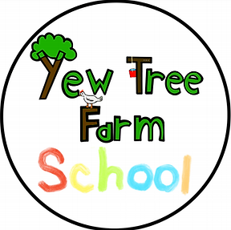

Risk Assessment / Absence Proforma

Unaccompanied Children and Young People

Please read through our generic Risk Assessment for all children and young people who attend Yew Tree Farm School unaccompanied. Every child will have their own risk assessment based on their specific needs. Please complete the form below before the young person has their first session at the farm.

A | School or Setting | Name of Child | Year |  | D.O.B⁽¹⁾
B | Does the young person present with any behaviour patterns that may present health and safety hazards?
C | What risks do they pose and to whom? |  |  |  |  | Estimate Risk Level H / M / L
D | What measures have you put in place in your setting to reduce the risks?⁽⁴ ⁻ ¹⁰⁾ |  |  |  |  | Risk Level Achieved  H / M / L
E | Does the young person have any physical difficulties that may present health and safety hazards?
F | What risks do they pose and to whom? |  |  |  |  | Estimate Risk Level H / M / L

G | What measures have you put in place in your setting to reduce the risks? |  |  |  | Risk Level Achieved  H / M / L

H | Is there anything else we need to know about the young person before completing our risk assessment?

If they child or young person does not attend their session at Yew Tree Farm School how would you like us to notify you? Please tick:

- – Register the absence on tapestry

- – Parent/Carer to inform the school /referring agency.

- Yew Tree Farm School staff to inform school / referring agency.

Parents / Carers need to inform Yew Tree Farm School if a student will be absent as soon as possible BEFORE the student’s session begins.

Form Completed By: ________________________________________

Role: ____________________________________________________

Date: ____________________________________________________

Signed: _____________________________________________________

If different -Name of Parent/Carer: __________________________________

Date: _________________________________________________________

Signed: _________________________________________________________

